**Advance Excel Assignment 6**

**By Abhishek Sachan**

**1. What are the various elements of the Excel interface? Describe how they're used.**

* Ribbon: The Ribbon is the main toolbar at the top of the Excel window. It contains all the major commands and tools that you'll use while working with Excel. The Ribbon is divided into tabs, which are organized by task.
* Quick Access Toolbar: The Quick Access Toolbar is a customizable toolbar that sits above the Ribbon. It provides quick access to frequently used commands, such as Save, Undo, and Redo.
* Formula Bar: The Formula Bar displays the contents of the active cell. You can also use the Formula Bar to enter or edit formulas and functions.
* Worksheets: Excel workbooks are made up of one or more worksheets. Each worksheet is a grid of cells that you can fill with data, formulas, and functions.
* Columns and Rows: Columns run vertically, while rows run horizontally. Together, they form a grid of cells that you can use to organize and analyze data.
* Cell: A cell is the intersection of a column and row. Each cell can contain data, formulas, and functions.
* Name Box: The Name Box displays the cell reference or range name of the active cell.
* Status Bar: The Status Bar displays information about the current status of Excel, such as the current mode and the number of selected cells.
* Zoom Slider: The Zoom Slider allows you to change the magnification level of the worksheet.

**2. Write down the various applications of Excel in the industry.**

Excel is a versatile tool that has numerous applications in various industries. Some of the common applications of Excel in the industry are:

* Data analysis and reporting: Excel is commonly used in data analysis and reporting. It allows users to analyze large datasets, create charts, and generate reports.
* Budgeting and financial analysis: Excel is widely used in financial analysis and budgeting. It allows users to create and manage budgets, perform financial calculations, and analyze financial data.
* Project management: Excel is a useful tool for project management. It allows users to create Gantt charts, track project progress, and manage project budgets.
* Sales and marketing: Excel is used in sales and marketing to manage customer data, create sales forecasts, and analyze market trends.
* Inventory management: Excel is used in inventory management to track inventory levels, manage stock, and generate inventory reports.
* Human resources: Excel is used in human resources to manage employee data, track attendance, and create employee schedules.
* Education: Excel is used in education to create gradebooks, track student progress, and manage school budgets.
* Research and data modeling: Excel is used in research and data modeling to perform statistical analysis, create predictive models, and analyze experimental data.

**3. On the ribbon, make a new tab. Add some different groups, insert commands in the groups and name them according to their commands added. Copy and paste the screenshot of the steps you followed.**

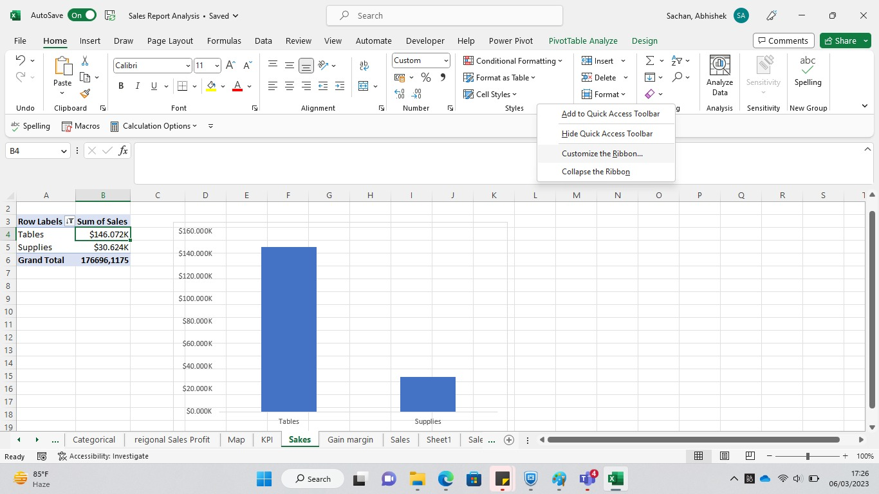

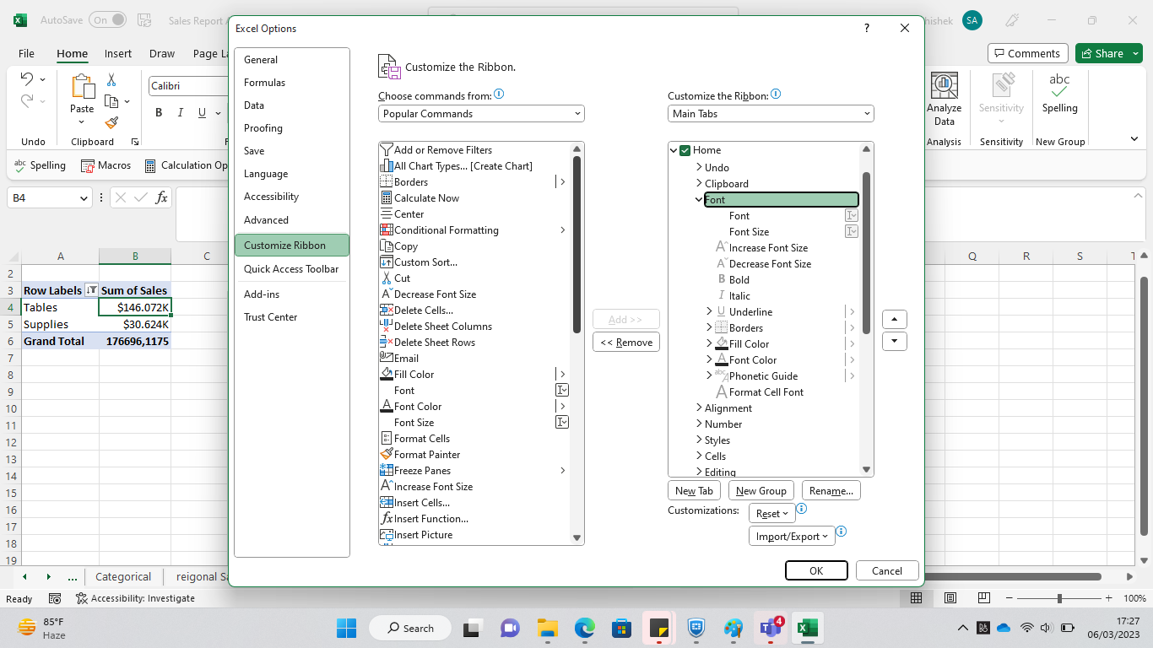

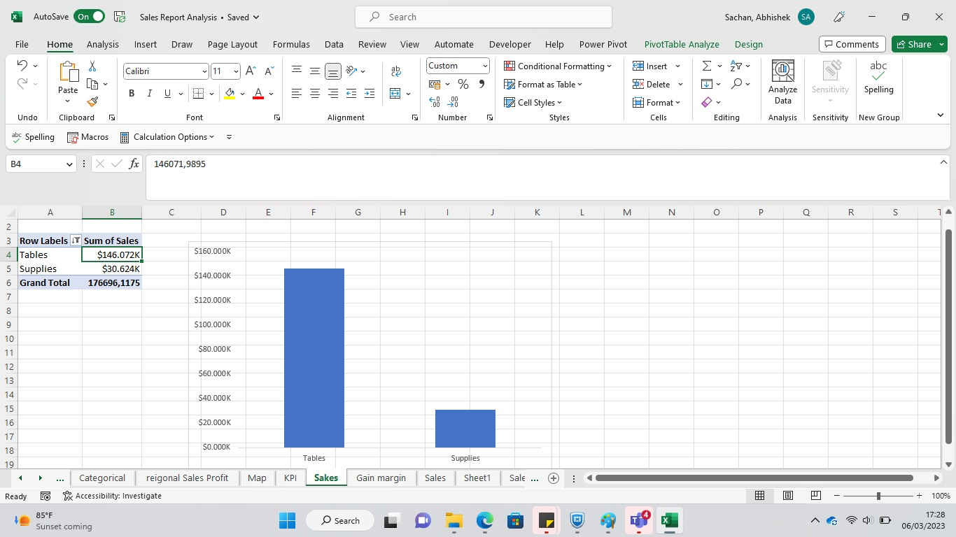

**4. Make a list of different shortcut keys that are only connected to formatting with their functions.**

* Ctrl+B: Apply bold formatting to the selected cells
* Ctrl+I: Apply italic formatting to the selected cells
* Ctrl+U: Apply underline formatting to the selected cells
* Ctrl+1: Open the Format Cells dialog box
* Ctrl+Shift+~: Apply General number format to the selected cells
* Ctrl+Shift+!: Apply Number format with two decimal places, comma separator and minus sign for negative values
* Ctrl+Shift+$: Apply Currency format with two decimal places and comma separator
* Ctrl+Shift+%: Apply Percentage format with no decimal places
* Ctrl+Shift+^: Apply Exponential number format with two decimal places
* Ctrl+Shift+#: Apply Date format with day, month and year
* Ctrl+Shift+@: Apply Time format with hour, minute and AM/PM
* Ctrl+Shift+&: Apply Border to the selected cells
* Ctrl+Shift+_ (underscore): Remove Border from the selected cells
* Ctrl+Shift+1: Apply Number format with comma separator and no decimal places
* Ctrl+Shift+2: Apply Time format with hour, minute, second and AM/PM
* Ctrl+Shift+3: Apply Date format with day, month and year
* Ctrl+Shift+4: Apply Currency format with two decimal places, minus sign for negative values and parentheses for positive values
* Ctrl+Shift+5: Apply Percentage format with one decimal place, comma separator and minus sign for negative values
* Ctrl+Shift+6: Apply Number format with comma separator, one decimal place and scientific notation

**5. What distinguishes Excel from other analytical tools?**

Excel is a powerful analytical tool that has been widely used for decades. Here are some of the distinguishing features of Excel compared to other analytical tools:

* User-friendly interface: Excel has a user-friendly interface that allows users to easily navigate through its various features and functions.
* Flexibility: Excel allows users to work with a wide range of data types, including text, numbers, and dates. It also offers various formatting and customization options to make the data more presentable.
* Wide range of features and functions: Excel provides a vast array of features and functions for data analysis, including built-in mathematical and statistical functions, charting tools, pivot tables, and macros.
* Integration with other Microsoft tools: Excel can easily integrate with other Microsoft tools such as Word and PowerPoint, making it easy to transfer data and information between applications.
* Accessibility: Excel is widely available and is installed on most computers. This makes it a convenient tool for data analysis for individuals and organizations.
* Cost-effectiveness: Excel is relatively inexpensive compared to other analytical tools and does not require extensive training to use effectively.

Overall, Excel's combination of user-friendliness, flexibility, features, and accessibility makes it a widely used and popular analytical tool for individuals and organizations of all sizes.

**6. Create a table and add a custom header and footer to your table.**

